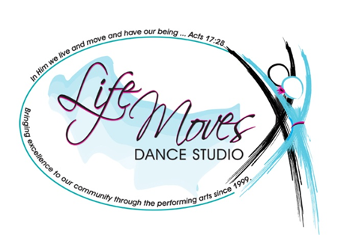
SAWMILL PLAZA
10747 HWY 144, RICHMOND HILL, GA 31324
OFFICE: 912-756-8482
TERESA: 912-667-6258
FACEBOOK: LIFE MOVES DANCE STUDIO
EMAIL: LIFEMOVESINFO@GMAIL.COM
WEBSITE: WWW.LIFEMOVESDANCE.COM
CELEBRATING OVER 15 YEARS OF SERVICE TO THE COMMUNITY!
…in Him we live and move and have our being… ACTS 17:28

Basic Birthday Party Contract
Parties can be scheduled on Saturday or Sundays at whatever time is convenient for your family (availability permitting). To reserve your party, please carefully read over and complete this contract and submit it along with your deposit of $50.00. Please pay your deposit by check and make the check payable to Life Moves Dance Studio. We also accept cash.
Party requests must be submitted a minimum of three weeks in advance.
We invite you to ask any questions or provide any special requests at least one week prior to the day of the party.
Birthday child’s info:
Full Name: ___________________________________________________________
Date of birth: _________________________________________________________
Gender (circle one): Boy Girl
Family Info:
Parent/guardian
Full Name: _________________________________________________________________________________
Address:____________________________________________________________________________________
____________________________________________________________________________________________
Phone: _____________________________________________________________________________________
Email (please print): _________________________________________________________________________
Party details:
Our basic party fee of $ 95.00 covers approximately 2-4 hours of party time.
Party date: _________________________________________________________
Party time and duration desired: ______________________________________
Number of attendees: _____ Children ___________ Adults
LMDS Party Policies:
- Our basic rate of $ 95.00 for your party only includes the use of our facility and the use of our equipment (radio, chairs, and tables). In the unlikely event that you or your guests do damage to our materials, equipment or property, you will be charged an additional fee based on the time and expense required to restore our facility to its pre-party condition.
- Setup, decoration, and cleanup is the sole responsibility of the person booking the party. If the premises is left messy, additional $25.00 will be billed.
- You must provide all food (including birthday cake), drinks, plates, cups, silverware, napkins, and, if desired, decorations.
- Birthday parties require a $50.00 deposit to reserve the date and time, with the remaining balance due on the day of the party in form of a check or cash. In the event that a party has to be cancelled a $10.00 fee will be deducted from the deposit.
Release
It is understood and agreed that I will abide by the LMDS Party Policies set forth herein and further that I will assume responsibility for any hazards on behalf of my child and all of the guests participating in the party and hereby waive, release and hold harmless LMDS owner, employees, and other participants from and against any and all claims, injuries, liabilities or damages arising out of or related to participation in the LMDS party event. The Terms shall serve as release and assumption of risk of all family and guests.

Parent or guardian’s name (please print):

______________________________________________________

Parent or guardian’s signature:

______________________________________________________

Today's date: _________________

We will contact you soon to confirm that we have received your contract.
We look forward to celebrating with you!

