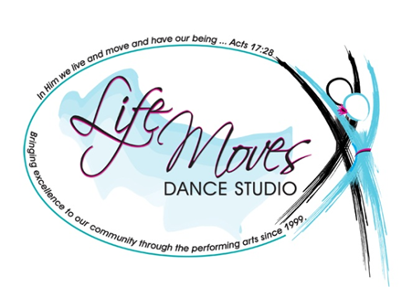
SAWMILL PLAZA
10747 HWY 144, RICHMOND HILL, GA 31324
OFFICE: 912-756-8482
TERESA: 912-667-6258
FACEBOOK: LIFE MOVES DANCE STUDIO
EMAIL: LIFEMOVESINFO@GMAIL.COM
WEBSITE: WWW.LIFEMOVESDANCE.COM
CELEBRATING OVER 15 YEARS OF SERVICE TO THE COMMUNITY!
…in Him we live and move and have our being… ACTS 17:28

Deluxe Birthday Party Contract
Parties can be scheduled on Saturday or Sundays at whatever time is convenient for your family (availability permitting). To reserve your party, please carefully read over and complete this contract and submit it along with your deposit of $75.00. Please pay your deposit by check and make the check payable to Life Moves Dance Studio. We also accept cash.
Party requests must be submitted a minimum of three weeks in advance.
We invite you to ask any questions or provide any special requests at least one week prior to the day of the party.

Birthday child’s info:
Full Name: ___________________________________________________________
Date of birth: _________________________________________________________
Gender (circle one): Boy Girl
Family Info:
Parent/guardian
Full Name: __________________________________________________________________________________
Address:__________________________________________________________________________________________________________________________________________________________________________________
Phone: _______________________________________________________________
Email (please print): ____________________________________________________
Deluxe Party details:
Our party fee of $ 150.00 covers approximately 2-4 hours of party time.
Party date: _________________________________________________________
Party time and duration desired: ______________________________________
Number of attendees:
_____ Children ___________ Adults
LMDS Party Policies:
- Our rate of $ 150.00 for your party includes the use of the space and all of LMDS’ materials and equipment, plus a teacher-assistant team who will lead the activities and help you with pre-party and post-party clean up. Pre-party setup time [limited to 30 minutes] and post-party cleanup time [limited to 30 minutes]. In the unlikely event that your party is unusually messy and takes more than 30 minutes for our staff to clean up, or that you or your guests do damage to our materials, equipment or property, you will be charged an additional fee based on the time and expense required to restore our facility to its pre-party condition.

- If you do not wish to use help with pre-party and post party setup or cleanup, LMDS will provide you a refund of $25.00.

- You must provide all food (including birthday cake), drinks, plates, cups, silverware, napkins, and, if desired, decorations.

- Although our deluxe party offers more than enough activities to keep your guests busy, if you wish, you are welcome to appoint additional entertainment (e.g., face painting).

- If there are any favorite songs or activities you want to be sure are a part of your child’s party, please let us know.

- Deluxe birthday parties require a $75.00 deposit to reserve the date and time, with the remaining balance due on the day of the party, in form of a check or cash. In the event that a party has to be cancelled a $10.00 fee will be deducted from the deposit.

Release
It is understood and agreed that I will abide by the LMDS Party Policies set forth herein and further that I will assume responsibility for any hazards on behalf of my child and all of the guests participating in the party and hereby waive, release and hold harmless LMDS owner, employees, and other participants from and against any and all claims, injuries, liabilities or damages arising out of or related to participation in the LMDS party event. The Terms shall serve as release and assumption of risk of all family and guests.

Parent or guardian’s name (please print):

_____________________________________________________________

Parent or guardian’s signature:

______________________________________________________________

Today's date: _________________

We will contact you soon to confirm that we have received your contract.
We look forward to celebrating with you!

